I/O INTERFACE PCB

- PARTS:

QUANTITY: PART #: NOMENCLATURE: LENGTH:

7 PER MACHINE 13521- CAP, .01μF, 50V N/A

1 PER MACHINE 13520- CAP, .1μF, 50V N/A

2 PER MACHINE 14046- CAP, 220μF, 16V N/A

1 PER MACHINE 17433-1L HEADER, 10-PIN, RT. ANGLE N/A

1 PER MACHINE 17628- CONNECTOR, PCB HEADER N/A

1 PER MACHINE 18656- RELAY, DPDT, 5VDC N/A

2 PER MACHINE 16246- NETWORK, RESISTOR, 330Ω, 10-PIN N/A

3 PER MACHINE 15372- RESISTOR, 10KΩ, ¼W, 5% N/A

3 PER MACHINE 15364- RESISTOR, 7KΩ, ¼W, 5% N/A

2 PER MACHINE 15348- RESISTOR, 1KΩ, ¼W, 5% N/A

3 PER MACHINE 15356- RESISTOR, 2.2KΩ, ¼W, 5% N/A

1 PER MACHINE 10231- IC, 74LS138, DECODER / MUX N/A

1 PER MACHINE 10179- IC, 74LS00, QUAD NAND GATE N/A

1 PER MACHINE 10160- IC, 74LS08N, QUAD AND GATE N/A

1 PER MACHINE 10395- IC, ULN2003, STEPPER DRIVER N/A

2 PER MACHINE 10234- IC, 74LS244, OCTAL BUS DRIVER N/A

4 PER MACHINE 18728- ARRAY, LED, 4X, RED N/A

3 PER MACHINE 17682- HEADER, STR, 2-PIN, GOLDPLATE N/A

1 PER MACHINE 17683- HEADER, STR, 4-PIN, GOLDPLATE N/A

3 PER MACHINE 17686- CONNECTOR, BNC, RT. ANGLE N/A

1 PER MACHINE 17680- CONNECTOR, DB37, MALE N/A

1 PER MACHINE 217071- PCB, BLANK, I/O INTERFACE N/A

1 PER MACHINE 17463-5 HEADER, STR., 26-PIN N/A

QUANTITY: PART #: NOMENCLATURE: LENGTH:

1 PER MACHINE 17463-1L HEADER, STR., 10-PIN N/A

- ASSEMBLY:

- INSERT AND SOLDER THE RESISTORS TO THE BOARD.

NOTE 1
THE GOLD BANDS ON ALL OF THE RESISTORS MUST FACE TOWARDS THE BOTTOM OF THE BOARD, OR TO THE RIGHT OF THE BOARD.

- INSERT AND SOLDER THE ICS TO THE BOARD.

C. INSERT AND SOLDER THE SMALLCAPACITORS AND RESISTOR NETWORKS TO THE BOARD.

NOTE 2
IT IS CRITICAL TO ALIGN PIN #1 OF THE RESISTOR NETWORKS WITH THE SQUARE HOLES ON THE BOARD.

- INSERT AND SOLDER THE LED ARRAYS TO THE BOARD.

- INSERT AND SOLDER THE RIGHT ANGLE HEADER INTO J2.

- INSERT AND SOLDER THE 4-PIN HEADER INTO J3.

- INSERT AND SOLDER THE FOUR MOLEX CONNECTORS TO THE BOARD.

- INSERT AND SOLDER THE TWO ELECTROLYTIC CAPACITORS INTO C4 AND C5.

NOTE 3
IT IS CRITICAL TO INSTALL THE TWO ELECTROLYTIC CAPACITORS WITH THE CORRECT POLARITY.

- INSERT AND SOLDER THE RELAY TO THE BOARD.

- INSERT AND SOLDER THE THREE BNC CONNECTORS TO THE BOARD.

- INSERT AND SOLDER THE TWO STRAIGHT HEADERS TO THE BOARD.

- INSERT THE DB37 CONNECTOR TO THE BACK OF THE BOARD.

NOTE 4
SEE DIAGRAM 1 FOR LAYOUT.

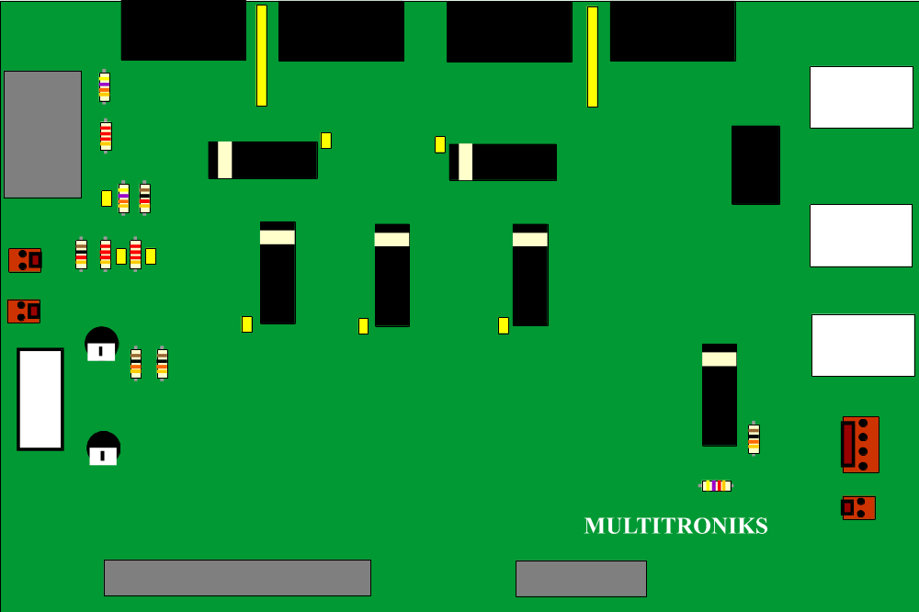

DIAGRAM 1

